What Happens During A Reaction?
- The collision theory
    - Two reacting molecules must collide
    - The collisions must occur with sufficient energy to disrupt the bonds in the reacting particles (activation energy). Without this minimum energy, the reactants will just collide and rebound off one another
    - In any given substance, there is a range of kinetic energies. This means that only some of the collisions will be effective as there will be many molecules who do not have sufficient kinetic energy for a reaction to take place
    - The particles must collide with one another in the correct orientation
- Energy and rate (energy profile diagrams)
    - Energy profile diagrams show the potential energy changes during the course of a chemical reaction
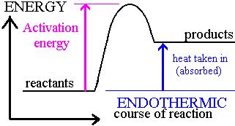
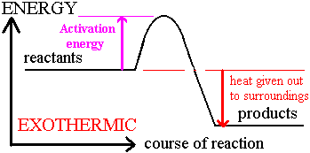

    - As the reactant molecules collide some of their kinetic energy is converted into potential energy (the potential energy of the system increases). This is due to the breaking of bonds and the rearrangement of atoms taking place in the colliding particles
    - If enough energy is available, then the system reaches the transition state. This is the maximum potential energy in the reaction. Bond breaking and bond forming is occurring at this stage. The transition stage only occurs for a brief instant
    - The Heat of Reaction is the difference in potential energy between the products and the reactants
    - Energy profile diagrams also provide information about the reverse reaction.
- Activation Energy
    - There is a certain amount of energy required for a reaction to take place
    - Many molecules have kinetic energy less than the required activation energy and therefore unable to react
    - For reactions to occur rapidly at room temperature, the activation energy is low, while it is high for reactions that are slow or do not occur readily at room temperature
    - Some exothermic reactions require high amount of activation energy, whilst others require a lower activation energy
    - Some endothermic reactions require high amount of activation energy, whilst others require a lower activation energy
Measuring Reaction Rates
The rate at which a reaction occurs can be quantitatively determined by:
- Measuring the amount of reactants used up
    - the mass of a reactant decreases
    - the concentration of a solution decreases
- Measuring the amount of products formed
    - The amount of a product increases
    - The volume of a gas increases
- The rate of a reaction can be determined by measuring any of these changes over a known time interval. For example:
Mass of reactant consumed
Rate of Reaction = Time interval

- The rate of reaction can be graphed
    - Amount of reactant or product on the vertical axis
    - Time on the horizontal axis
    - The slope of the graph at a particular time is the measure of the reaction rate at that time- the steeper the slope, the faster the reaction rate
    - The reaction rate is generally fastest at the beginning at then slows as the reactants are used up
    - The instantaneous rate is measured by determining the tangent to the curve at a particular time and dividing the run by the rise (volume change in products divided by time)
Factors Affecting Reaction Rates
- Nature of the Reactants
    - What are the substances reacting together?
    - Some substances will react very quickly, whilst others slowly
    - Reactions involving the breaking and forming of covalent bonds tend to occur slower than the simple combination of oppositely charged ions.
    - Collisions involving molecules must have sufficient energy and react with the correct orientation for the reaction to occur
    - Ions generally combine together very quickly and do not have to overcome high energy requirements
- Concentration of the Reactants
    - More concentrated solutions contain greater amounts of ions in a particular volume
    - Increased number of ions mean more collisions will occur between the reactant particles
    - Increased chance that reactions will occur with sufficient energy and the favoured orientation for the reaction to occur
- State of Subdivision of the Reactants
    - Cutting a substance into smaller pieces increases its surface area and therefore increases the number of collisions and hence the reaction rate
- Temperature
    - Increasing the temperature of the reactants increases the kinetic energy of the particles which increases the chance of collisions with sufficient energy for the reaction to occur
- Catalysts
    - Catalysts speed up a reaction by reducing the activation energy of a chemical reaction
    - The catalyst is not involved in the chemical reaction and can be re-used over and over again
    - Lowering the activation energy means that more particles will have the required energy to react- more collisions will result in a reaction, increasing the reaction rate
    - Sometimes catalysts provide a surface for chemical reactions to occur and therefore improve the colliding orientation
    - Catalysts are written above the molecular equation to show that it is not consumed but plays an important role in the reaction

